FROM NOOB TO PRO: BASICS

THIS ARTICLE WILL REVIEW CLASS, WEAPONS, KEYBINDS and GAMEMODES

In this article, we will cover the basics of AAPG, including the functions of each Class, Weapons, Game Settings, Gamemodes and so forth.

#CLASS

#WEAPONS

#KEYBINDS

#GAMEMODES

#GAMEMECHANICS

CLASSES PART 1 of 1

First up, class. There are four different classes in AAPG:

* Rifleman
* Automatic Rifleman
* Designated Marksman
* and Sniper

Each class has their own functions and are equally important. However, having too many of one but not the other will lead to disastrous results.

By default, the class are split like so:

* ∞ Rifleman
* 2 Automatic Rifleman
* 2 Designated Marksman
* 1 Sniper

However, these may change depending on the server and map you play on.

Each class serves their own purpose, and each class has different playstyles. Typically, the Riflemen and Auto-riflemen are front-line fighters. The Riflemen provide the accuracy in close to medium range, while the auto-riflemen suppress fire. Meanwhile, Designated Marksmen and Snipers cover the front-line fighters from a distance. Usually, the sniper stays behind, shooting from long range, while designated-marksmen will always shoot from medium to long range.

How each class is played changes with the map design, and I will cover them in future articles.

WEAPONS

There are many different weapons for you to choose from. From short-range shotguns to longer range sniper rifles, each gun is suited for a different task, and each will allow you to customize. Each class has different weapons, and here they are listed:

* Rifleman
  + M1A1 Carbine
  + M16A4 Rifle
  + Remington 870 MCS
* Automatic Rifleman
  + M249 SAW
* Designated Marksman
  + M14EBR-RI Rifle
  + M16A4 Rifle
* Sniper
  + M14EBR-RI Rifle
  + M24 Sniper Rifle

Each weapon is fitted for each class, even the ones that are shared between classes. However, while each weapon is powerful if used properly, each weapon is suited for different situations, and each should be used strategically.

Also, while both the Designated Marksman and Sniper classes have 2 weapons, you should try to use the M14EBR-RI Rifle and M24 Sniper Rifle, respectively. This is because of the damage they deal, which we will talk about later. We will talk about these weapons more in depth later.

KEYBINDS

Now, the most important part about AAPG, and the thing that will increase your skill tenfold, is key-binds. I cannot stress the importance of key-binds: they will drastically change your gaming experience. Each and every bind should be mapped for maximum efficiency; to allow you make game-changing moves. For example, my key-binds look like this:

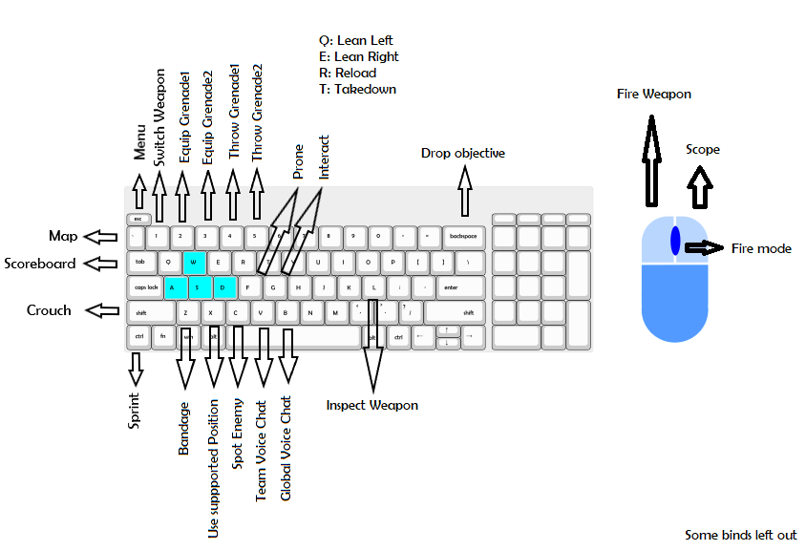

As you can see, all of my more important key-binds are mapped very close together. This is to maximize efficiency; so I can shoot with my right hand and do everything else with my left, all while focusing completely on the game. Because my keys are so closely mapped together, I can use a variety of combinations to make my chances of surviving better. Furthermore, less important binds are placed farther away. Keys for Inspecting weapons, dropping objectives, interacting, and global voice chat are all far away for one reason: because they should not be done unless the immediate area is completely safe and secured. That way, when performing these actions, you have a very miniscule chance of having to quickly switch to other keys to defend yourself.

GAMEMODES

There are two different types of missions: FLO, and BDX. FLO stands for Forward Line Operations, and take place in larger maps using a 12v12 roster. BDX stands for Battle Drill Exercise, and uses a 6v6 fire squad format.

<http://assets.americasarmy.com/AAProvingGroundsQuickstartGuidev4.pdf>

<https://forum.americasarmy.com/discussion/6200/descriptions-of-the-game-types>

(NOTE: These sources are outdated, and most of the information involves a different edition of America’s Army).

There are 5 different gamemodes in AAPG: Extract, Activate, Take and Hold, C4, and VIP.

**Extract** (Ex)  
● The Assault team must locate and secure the objective, represented by the 2/56 LRCAR  
Guidon Flag.  
● After securing the objective, the Assault team must carry the flag to the marked extract  
location  
● If the flag carrier is neutralized, the flag is dropped where it will remain until either it is  
picked up again or the round ends.  
● The Defense team cannot interact with the Guidon Flag. Their only mission is to  
neutralize the entire Assault team before they can move the flag to the extraction zone.  
● If the entire Defense team is neutralized, Assault wins the round. If time expires before  
the flag reached the extraction zone, Defense wins.  
  
**Activate** (AC)  
● The Assault team is tasked with locating up to 3 devices placed around the level.  
● Activating the devices requires 8 seconds of uninterrupted interaction.  
● Defense cannot interact with the objectives. Their only mission is to neutralize the entire  
Assault team before they can activate all of the devices.  
● If the entire Defense team is neutralized, Assault wins the round. If time expires before  
Assault activates all of the devices, Defense wins.

**VIP**  
● The Escort team must escort the VIP to the extract point  
● Defense is tasked with taking down and securing the VIP.

● If the VIP escapes or the Defense team is neutralized, the game ends and Escort team wins.  
● If the entire Escort team is neutralized or the VIP is secured, Defense wins the round. If the timer expires, Defense scores the win.

**Take and Hold** (TH)  
● At the start of each round, all objectives are flagged as neutral  
● Activate each objective to secure it  
● Once you’ve secured an objective you must defend it because the opposing team can  
take it from you  
● To win, a team must have all the objectives secured at the same time  
● Communication and planning are the key to your team’s success

**C4** (C4)  
● To win, the assault team must place an explosive device at one of two objective  
locations  
● The defenders must prevent this by either disarming a placed explosive charge, or  
eliminating the entire assault force  
● The defenders may also win by securing the explosive if it has been dropped

GAMEMECHANICS PART 2 of 2

In this section, we will talk about game mechanics, and more specifically, the statistics of each weapons.

First and foremost, damage in AAPG is calculated like so: (may be inaccurate)

|  |  |  |
| --- | --- | --- |
| Location | Instant Damage (in %) | Bleed out damage (in %) |
| Head | 400% | 20% |
| Arms | 65% | 30% |
| Upper torso | 65% | 30% |
| Lower torso | 55% | 60% |
| Legs | 45% | 45% |

Those percentages are the multipliers for damage stats of each weapon. Before we get into that, however, a bit more on hitboxes.

Wikipedia defines hitboxes as “an invisible shape commonly used in video games for real-time collision detection.” While this is true, it also contains flaws. In programming, hitboxes are not “invisible” shapes, but rather a complex algorithm that sends data concerning entity-on-entity collisions. While hitboxes are relatively easy to create in 2D games, they are far more complicated in 3D. To make the “perfect” hitbox in 3D games, a programmer would have to create small boxes for every single pixel that the entity model takes up.